SESSION-2
2.
Create a new database named 'foodie_app' to simulate a Zomato-style backend.
CREATE DATABASE foodie_app;
USE foodie_app;
3.
Write a CREATE TABLE statement to define a 'restaurants' table in the 'foodie_app' database with the following columns: id (integer, primary key), name (varchar/character, max 100), cuisine (varchar/character, max 50), rating (decimal, e.g., 4.5), and location (varchar/character, max 100).
CREATE TABLE restaurants (
id INT PRIMARY KEY,
name VARCHAR(100),
cuisine VARCHAR(50),
rating DECIMAL(3, 1),
location VARCHAR(100) );
4.
Design and create a 'users' table for a Flipkart-style app with columns: user_id (primary key), username, email, phone_number, and created_at (date/time). Pick appropriate data types for each column.<br><br><em><strong>Hint:</strong> Think about which columns should be unique and which data types best fit email and phone numbers.</em>

CREATE TABLE users (
user_id INT PRIMARY KEY,
username VARCHAR(50) NOT NULL UNIQUE,
email VARCHAR(255) NOT NULL UNIQUE,
phone_number VARCHAR(20) NOT NULL UNIQUE,
created_at TIMESTAMP DEFAULT CURRENT_TIMESTAMP );

5. Intentionally make a mistake in your CREATE TABLE statement (such as missing a comma or using an unsupported data type), run it, and then fix the error based on the message you receive.<br><br><em><strong>Hint:</strong> Take a screenshot of the error and the corrected SQL statement for your records.</em>
CREATE TABLE products (
product_id INT PRIMARY KEY,
product_name VARCHAR(100) NOT NULL
price DECIMAL(10, 2) NOT NULL,
stock_quantity INT
);
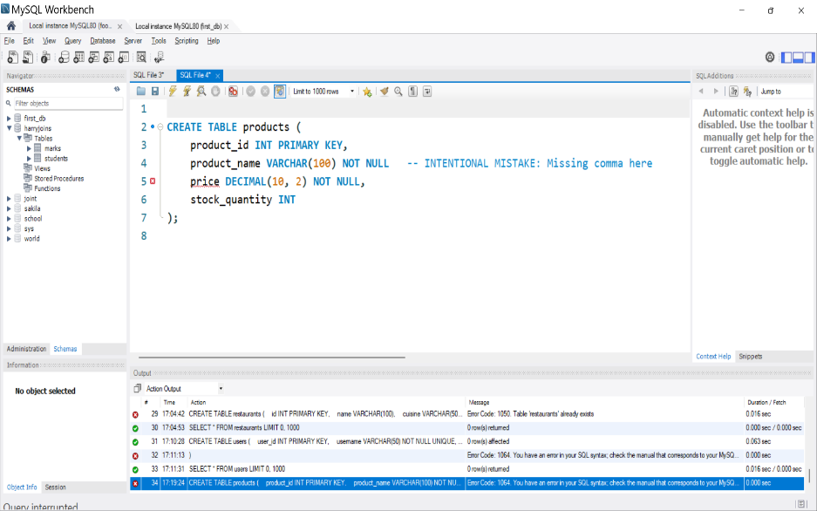
The blue outline text shows the error , we have to again amalyze and make the changes to run the querry successfully .
CREATE TABLE products (
product_id INT PRIMARY KEY,
product_name VARCHAR(100) NOT NULL, -- FIXED: Comma added here
price DECIMAL(10, 2) NOT NULL,
stock_quantity INT );
d